## **Project 01**

### **Objectives:**

* Create and manage Docker volumes for data persistence.
* Set up a Docker network for container communication.
* Use Docker Compose to manage multi-container applications.
* View and manage Docker logs.
* Deploy the application using Docker Swarm.
* Modify and redeploy the application.

### **Project Outline:**

1. **Create Docker Volumes**
2. **Create a Docker Network**
3. **Write a Docker Compose File**
4. **Deploy the Application with Docker Compose**
5. **Manage Docker Logs**
6. **Deploy the Application Using Docker Swarm**
7. **Modify and Redeploy the Application**

### **Step-by-Step Guide**

#### **1. Create Docker Volumes**

Docker volumes are used to persist data generated by and used by Docker containers.

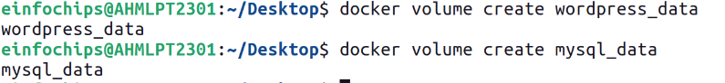

#### **2. Create a Docker Network**

Create a custom network for the containers to communicate.



#### **3. Write a Docker Compose File**

Create a docker-compose.yml file to define and manage the services.

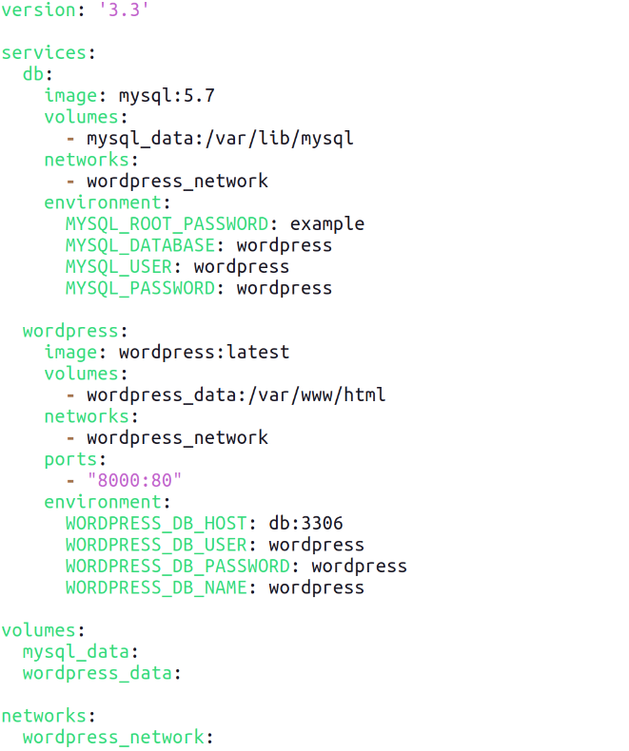

#### **4. Deploy the Application with Docker Compose**

Run the following command to start the services defined in the docker-compose.yml file.

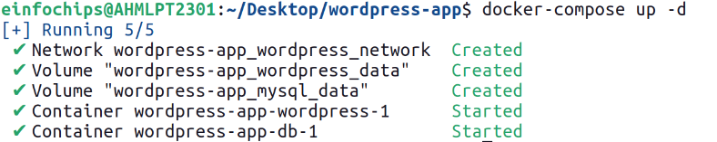

Verify that the containers are running.



Access the WordPress setup by navigating to [http://localhost:8000](http://localhost:8000/).

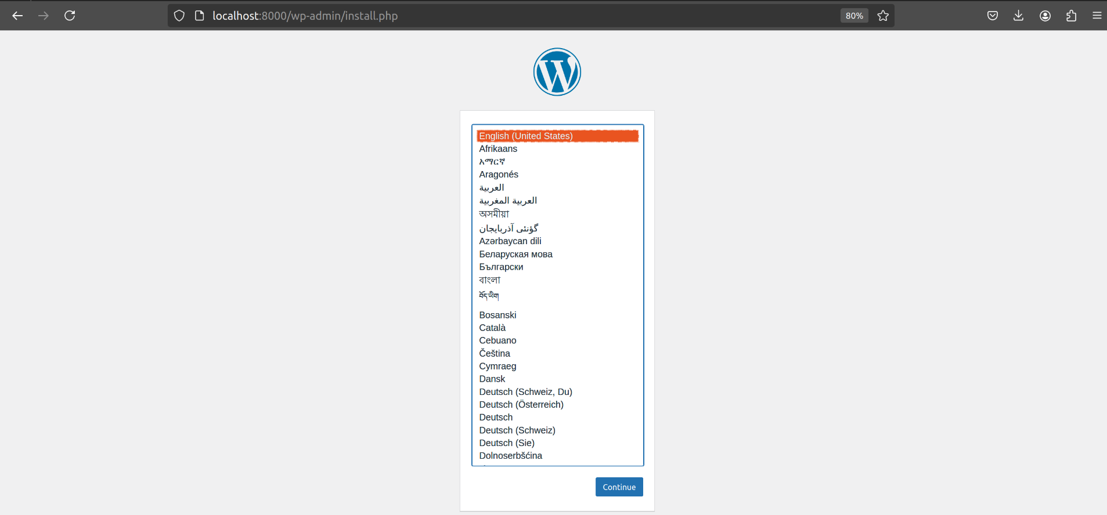

#### **5. Manage Docker Logs**

View logs for a specific service.



Follow logs for real-time updates.



#### **6. Deploy the Application Using Docker Swarm**

Docker Swarm is a native clustering and orchestration tool for Docker.

Initialize Docker Swarm.

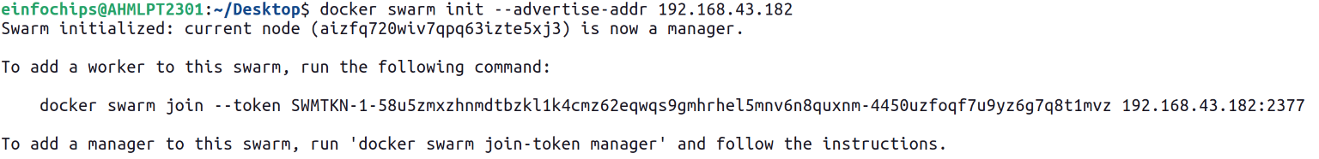

Convert the Docker Compose file to a Docker Stack file, docker-stack.yml.



Deploy the stack using Docker Swarm.



Verify the stack is running.



#### **7. Modify and Redeploy the Application**

Make modifications to the application or the stack file as needed. For example, change the number of replicas:

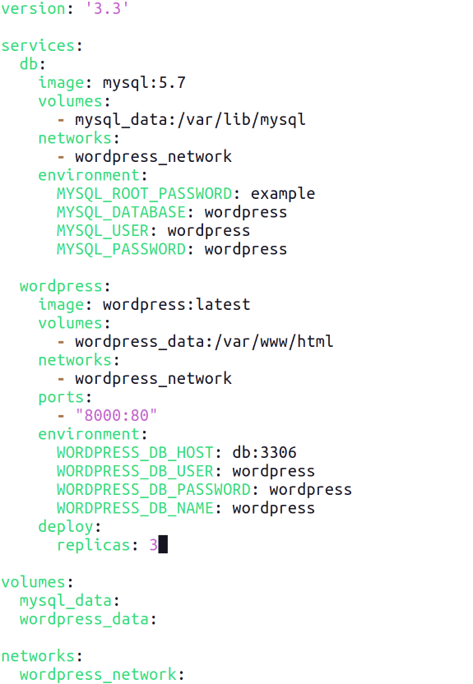

Update the stack with the new configuration:

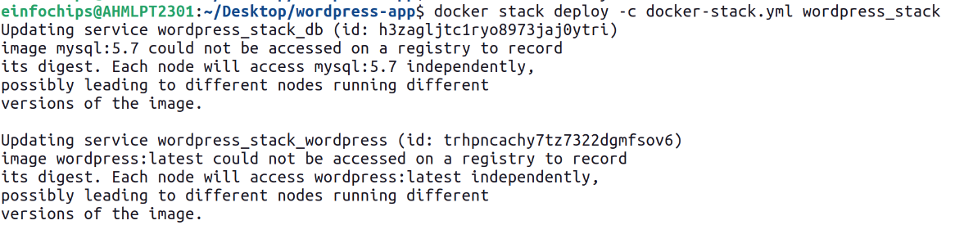Verify the changes:

